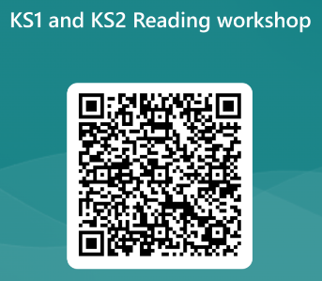

Reading at Trinity
BoomReader


This year we have moved on to new online reading records through BoomReader.
Children will have their own QR code and PIN number where they can access their account to add new books and log when they read at home.
Parent letters can also be generated from the site with log in information on.

For now, our homework focus for this year is reading with the expectation that children will read 5 times a week at home. This can be a book of their choice, their book from the Bug Club scheme or a recommended read from the class library.

Please see your child’s class teacher if you have any queries relating to BoomReader.

Children who read 5 times a week will be entered into a half-termly reading raffle with exciting book-related prizes!
We will be hosting a Reading workshop for parents on Thursday 16th November at 2.30pm and 5pm. Please use the QR code to sign up:
Reasons to read
- Daily reading results in hearing a whopping 296,660 new words a year to add to vocabulary.
- - Reading helps to develop empathy and social skills in children, through reading about characters and situations that they can relate to.
- - Shared reading experiences can foster more positive attitudes to reading.
- - Reading for pleasure can help with health, wellbeing and emotions.

We put our HEART into reading.
Here is some information on reading at Trinity and to share when reading with your child at home.
Helpful questions to ask when reading:
- Look at the front cover. What could the book be about?
- Who is the author?
- What does this word mean? Use the clues around the text help you.
- Who are the main characters?
- What do you think will happen next?
- How do you think this character feels? How would you feel in that situation?
- Can you predict how the book will end?
- Who is your favourite character and why?
- Are you enjoying this book? Why?
- What do you think this book is trying to teach us?
Book Talk
Sometimes children like to hear a book being read to them, as much as they like reading them. Book talk is a great way to discuss what has been read in an informal way and also develop comprehension. Here are some reading skills used in Book Talk sessions in school during whole class reading.
- Make predictions and think about what could happen in the story
- Make comparisons with other texts. Discuss differences and similarities with other shared books.
- Discuss what questions you might have about the book and what you would want to find out.
- Discuss the meaning of words in context. Can you work out the meaning of tricky words?

