Suggested Reading List for Year 6
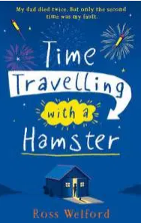
- A Boy Called Hope by Lara Williamson
- Illegal by Eoin Colfer
- The Nowhere Emporium by Ross Mackenzie
- Time Travelling with a Hamster by Ross Welford
- Cogheart by Peter Bunzl
- Eren by Simon P. Clark
- The Girl of Ink and Stars by Kiran Milwood Hargrave
- The Railway Children by E.Nesbitt
- Abomination by Robert Swindells
- Carrie’s War by Nina Bawden
- The Crowstarver by Dick King-Smith
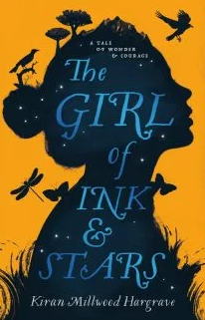
- Raspberries on the Yangtze by Karen Wallace
- Awful End by Philip Ardagh
- On Hereabout Hill by Michael Morpurgo
- Fruit and Nutcase by Jean Ure
- Granny by Antony Horowitz
- The Hobbit by JRR Tolkien
- Lionboy by Zizou Corder
- The Machine Gunners by Robert Westall
- The Viewer by Gary Crew
- My Swordhand is Singing by Marcus Sedgwick
- Once by Morris Gleitzman
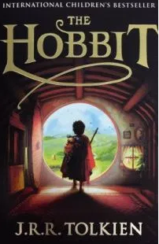
- The Other Side of the Truth by Beverley Naidoo
- Skellig by David Almond
- The Silver Sword by Ian Serraillier
- Tell Me No Lies by Malorie Blackman
- Superfudge by Judy Blume
- The Weathermonger by Peter Dickinson
- What Katy Did by Susan Coolidge
- The Wheel of Surya by Jamila Gavin
- Goodnight Mr Tom by Michelle Magorian
- Why the Whales Came by Michael Morpurgo
- The Borrowers by Mary Norton
- Silverfin by Charlie Higson
- Oranges in No Man’s Mand by Elizabeth Laird
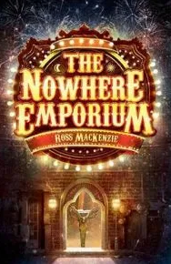
- The Wild Folk by Sylvia Linsteadt
- The Eye of the North by Sinead O’Hart
- The Many Worlds of Albie Bright by Christopher Edge
- The True Colours of Coral Glen by Juliette Forrest
- Dragon Rider by Cornelia Funke
- Sky Hawk by Gill Lewis
- Tin by Padraig Kenny
- Just Call Me Spaghetti Hoop Boy by Lara Willamson
- Welcome to Nowhere by Elizabeth Laird
- See You in the Cosmos by Jack Cheng
- Rumble Star by Abi Elphinstone
- Boy Under Water by Adam Baron
- Kat Wolfe Investigates by Lauren St John
- The Skylark’s War by Hilary McKay
- Alex Rider Stormbreaker by Anthony Horowitz
- Wonder by R.J Palacio
- Gaslight by Eloise Williams
- Clockwork by Philip Pullman
- Dreaming the Bear by Mimi Thebo
- Holes by Louis Sachar
- Northern Lights Trilogy by Philip Pullman
- The House with Chicken Legs by Sophie Anderson
- Rooftoppers by Katherine Rundell

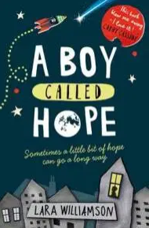
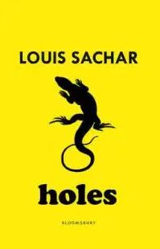
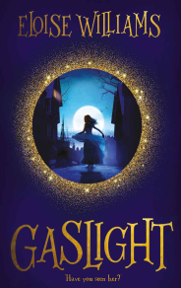
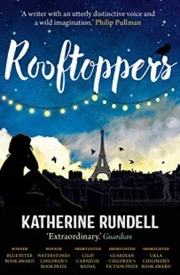

Suggested Reading List for Year 5
- Wolf Brother by Michelle Paver
- Against All Gods by Maz Evans (sequel to class text Who Let The Gods Out)
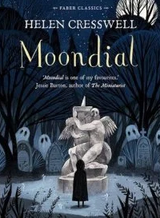
- Beetle Boy by MG Leonard
- Boy in the Tower by Polly Ho-Yen
- The Wolf Wilder by Katherine Rundell
- The Explorer by Katherine Rundell
- Heidi by Johanna Spyri
- Artemis Fowl by Eoin Colfer
- The Breadwinner by Deborah Ellis
- The Butterfly Lion by Michael Morpurgo
- Clockwork by Philip Pullman
- Danny the Champion of the World by Roald Dahl
- Dial a Ghost by Iva Ibbotson
- Journey to the River Sea by Iva Ibbotson
- Dragon Rider by Cornelia Funke
- Emil and the Detectives by Erich Kästner
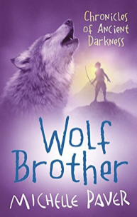
- The Incredible Adventures of Professor Branestawm by Norman Hunter (perfect for those interested in inventions and science)
- I Know What You Did Last Wednesday by Anthony Horowitz
- Peter in Peril by Helen Bate
- The Ghost of Thomas Kempe by Penelope Lively
- Harry Potter and the Goblet of Fire by JK Rowling
- Harry Potter and the Prisoner of Azkaban by JK Rowling
- The Hundred and One Dalmatians by Dodie Smith
- Krindlekrax by Philip Ridley
- Scribbleboy by Philip Ridley
- Stig of the Dump by Clive King
- Hacker by Malorie Blackman
- When Hitler Stole Pink Rabbit by Judith Kerr
- Moondial by Helen Cresswell
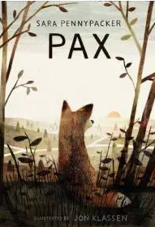
- The Demon Headmaster by Gillian Cross
- The Witches by Roald Dahl
- Bill’s New Frock by Anne Fine
- The Mouse and his Child by Russell Hoban
- King of the Forest Clouds by Michael Morpurgo
- The Phoenix and the Carpet by E.Nesbit
- A Series of Unfortunate Events by Lemony Snicket
- Woof! By Allan Ahlberg
- The Peculiars by Kieran Larwood
- The Girl with the Shark’s Teeth by Cerrie Burnell
- Fortunately the Milk by Neil Gaiman
- Twister by Juliette Forrest
- Ever dark by Abi Elphinstone
- When the Mountains Roared by Jess Butterworth
- The Last Chance Hotel by Nicki Thornton
- The Boy Who Flew by Fleur Hitchcock
- Wildspark by Vashti Hardy
- A Place Called Perfect by Helena Duggan
- Goldfish Boy by Lisa Thompson
- The Last Wild by Piers Torday
- The Unforgotten Coat by Frank Cottrell Boyce
- Running on the Roof of the World by Jess Butterworth
- Coraline by Neil Gaiman
- Malamander by Thomas Taylor
- The 1000 Year Old Boy by Ross Welford

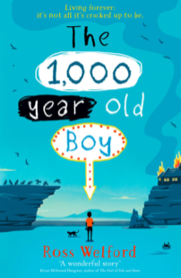
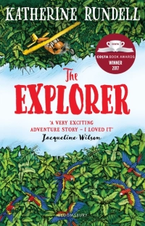
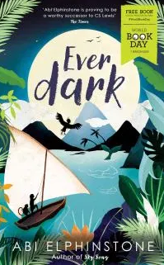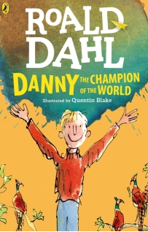

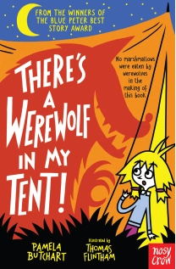
Suggested Reading List for Year 4
- Max and the Millions by Ross Montgomery
- Desirable by Frank Cottrell Boyce
- My Brother is a Superhero by David Solomons
- There’s A Werewolf in my Tent by Pamela Butchart
- The 13 Story Treehouse by Andy Griffiths
- Harry Potter and the Chamber of Secrets by JK Rowling
- The Peppermint Pig by Nina Bawden
- Operation Gadgetman! By Malorie Blackman
- How To Train Your Dragon by Cressida Cowell
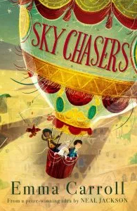
- Lizzie Dripping by Helen Cresswell
- The Great Elephant Chase by Gillian Cross
- The Twits by Roald Dahl
- Charlie and the Chocolate Factory by Roald Dahl
- War Game by Michael Foreman
- Toad Rage by Morris Gleitzman
- The Falcon’s Malteser by Anthony Horowitz
- The Hodgeheg by Dick King Smith
- The Worst Witch by Jill Murphy
- The Firework Maker’s Daughter by Philip Pullman
- The Way to Sattin Shore by Philippa Pearce
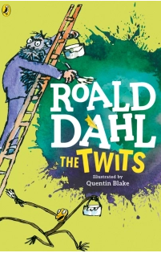
- The Suitcase Kid by Jacqueline Wilson
- George’s Marvellous Medicine by Roald Dahl
- Billionaire Boy by David Walliams
- The Legend of Captain Crow’s Teeth by Eoin Colfer
- The Amazing Story of Adolphus Tips by Michael Morpurgo
- The Yearling by Marjorie Rawlings
- The Reluctant Dragon by Kenneth Grahame
- The Truth Pixie by Matt Haig
- The Demon Headmaster by Gillian Cross
- Amelia Fang and the Barbaric Ball by Laura Ellen Anderson
- The Wizards of Once by Cressida Cowell
- Sky Chasers by Emma Carroll
- The Phantom Booth by Norton Juster
- Iron Man by Ted Hughes
- Giant by Kate Scott
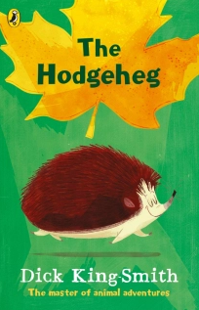
- The Dragon with a Chocolate Heart by Stephanie Burgis
- Perfectly Norman by Tom Percival
- Ottoline and the Yellow Cat by Chris Riddell
- The Legend of Podkin One Ear by Kieran Larwood
- Perijee and Me by Ross Montgomery
- Zoo Boy by Sophie Thompson
- There May Be a Castle by Piers Torday
- I Swapped my Brother on the Internet! By Jo Simmons
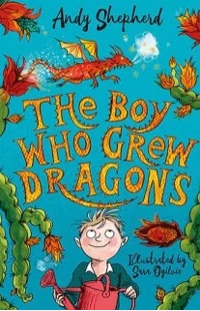
Suggested Reading List for Year 3
- The Accidental Prime Minister by Tom McLaughlin
- The Boy Who Grew Dragons by Andy Shepherd
- Varjak Paw by SF Said
- Dog Man by Dav Pilkey
- King Kong by Anthony Browne
- Beast Quest Series by Adam Blade
- The Abominables by Eva Ibbotsen
- Ice Palace by Robert Swindells
- Kid Normal by Greg James
- The World According to Humphrey by Betty G. Birney
- Harry the Poisonous Centipede by Lynne Reid Banks
- Dilly the Dinosaur by Tony Bradman
- The Invisible Boy by Trudy Ludwig
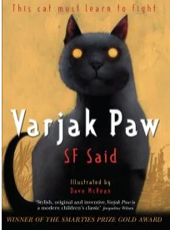
- The Secret World of Polly Flint by Helen Cresswell
- Fantastic Mr Fox by Roald Dahl
- The Magic Finger by Roald Dahl
- Wilf the Mighty Worrier Saves the World by Georgia Pritchett
- Willa and Old Miss Annie by Berlie Doherty
- Animal Ark series by Lucy Daniels
- The Diary of a Killer Cat by Anne Fine
- Picasso Perkins by Adele Geras
- All Because of Jackson by Dick King Smith
- Mrs Pepperpot Stories by Alf Proysen
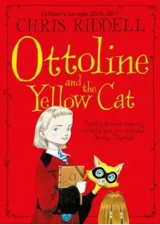
- Unusual Day by Sandi Toksvig
- The Bolds by Julian Clary
- The Grunts in Trouble by Philip Ardagh
- Ariki and the Giant Shark by Nicola Davies
- Erica’s Elephant by Sylvia Bishop
- Arlo, Mrs Ogg and the Dinosaur Zoo by Alice Hemming
- Oliver and the Seawigs by Philip Reeve and Sarah McIntyre
- Hotel Flamingo by Alex Milway
- Stitch Head by Guy Bass
- Witch for a Week by Kaye Umansky
- The Adventures of Harry Stevenson by Ali Pye
- The Adventures of Ermine (who is very determined) by Jennifer Gray
- We Won an Island by Charlotte Lo
- Isadora Moon Goes to the Ballet by Harriet Muncaster
- Mr Majeika by Humphrey Carpenter
- The Secret Seven: Mystery of the Skull by Enid Blyton
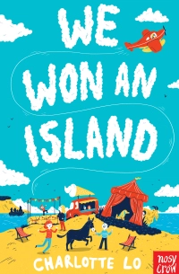
- Mariella: Queen of the Skies by Eoin Colfer
- Spy Toys by Mark Powers
- Toto the Ninja Cat and the Great Snake Escape by Dermot O’Leary
- The Dragonsitter by Josh Lacey
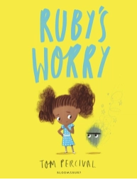
- The Enchanted Wood by Enid Blyton
- Ruby’s Worry by Tom Percival
- Marge in Charge by Isla Fisher
- Ellie and the Cat by Malorie Blackman
- Dave Pigeon by Swapna Haddow
- The Magic Faraway Tree by Enid Blyton

Suggested Reading List for Year 2
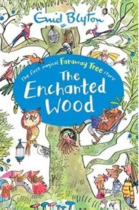
- Salty Dogs by Matty Long
- Don’t Look in this Book by Samuel Langley-Swain
- The Legend of Spud Murphy by Eoin Colfer
- Jinnie Ghost by Berlie Doherty
- I Was A Rat by Philip Pullman
- Beaver Towers by Nigel Hinton
- Triangle by Mac Barnett
- Fungus the Bogeyman by Raymond Briggs
- Mrs Wobble the Waitress by Allan Ahlberg
- The Adventures of Captain Underpants by Dav Pilkey
- The Dunderheads by Paul Fleischman
- The Giraffe and the Pelly and Me by Roald Dahl
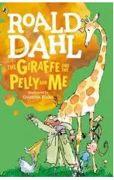
- Uncle Gobb and the Dread Shed by Michael Rosen
- Mr Wolf’s Pancakes by Jan Fearnley
- Gobbolino the Witch’s Cat by Ursula Williams
- The Enchanted Wood by Enid Blyton
- Clarice Bean, That’s Me by Lauren Child
- Nim’s Island by Wendy Orr
- The Tear Thief by Carol Ann Duffy
- The Penderwicks by Jeanne Birdsall
- Star in the Jar by Sam Hay
- Sam Wu is Not Afraid of Ghosts by Katie and Kevin Tsang
- Cowboy Pug by Laura James
- Superdad’s Day Off by Phil Earle
- The Hen Who Wouldn’t Give Up by Jill Tomlinson
- There’s a Tiger in the Garden by Lizzy Stewart
- Wild by Emily Hughes
- Gaspard Fox by Zeb Soanes and James Mayhew
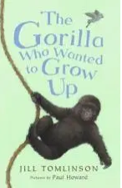
- The Last Wolf by Mini Grey
- Mr Tiger Goes Wild by Peter Brown
- The Gorilla who Wanted to Grow Up by Jill Tomlinson
- The Unbelievably Top Secret Diary of a Pig by Emer Stamp
- Mummy Fairy and Me by Sophie Kinsella
- How the Whale Became and other stories by Ted Hughes
- The Wrong Pong by Stephen Butler
- Dragon Post by Emma Yarlett
- The Day the Crayons Quit by Oliver Jeffers
- One Christmas Wish by Katherine Rundell
- Flat Stanley by Jeff Brown
- The King who Banned the Dark by Emily Haworth-Bloom
- The Bear and the Piano by David Litchfield
- Norman, the Norman from Normandy by Philip Ardagh
- Stuart Little by EB White
- Tidy by Emily Gravett
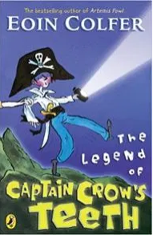
- Claude in the City by Alex T.Smith
- Milton the Mighty by Emma Read
- The Storm Whale by Benji Davies
- Daisy and the Trouble with Life by Kes Gray
- The Owl Who Was Afraid of the Dark by Jill Murphy

Suggested Reading List for Year 1

- Cinnamon by Neil Gaiman
- I Can Only Draw Worms by Will Mabbitt
- Goodnight, Everyone by Chris Haughton
- Funnybones by Allan Ahlberg
- The Gruffalo by Julia Donaldson
- A Bear Called Paddington by Michael Bond
- A Lion in the Meadow by Margaret Mahy
- Hairy Maclary from Donaldon’s Dairy by Lynley Dodd
- Owl Babies by Martin Waddell
- The Emperor of Absurdia by Chris Riddell
- Mister Magnolia by Quentin Blake
- Katie Morag’s Island Stories by Mairi Hedderwick
- Meg and Mog by Helen Nichol
- Not Now, Bernard by David Mckee
- A Dark, Dark Tale by Ruth Brown
- Dogger by Shirley Hughes
- I Want my Hat Back by John Klassen
- The Dark by Lemony Snicket
- You Can’t Take An Elephant on the Bus by Patricia Cleveland-Peck
- Penguin by Polly Dunbar
- You Choose! By Pippa Goodheart
- Stanley’s Stick by Neale Layton and John Hegley
- What To Do If An Elephant Stands on Your Foot by Michelle Robinson
- How to Wash A Woolly Mammoth by Michelle Robinsong
- Dinosaurs in the Supermarket by Timothy Knapman
- The Adventures of the Dish and the Spoon by Mini Grey
- Room on the Broom by Julia Donaldson
- The Snail and the Whale by Julia Donaldson
- Three Cheers of Errol by Babette Cole
- Lost and Found by Oliver Jeffers
- Toys in Space by Mini Grey
- Sophie’s Snail by Dick King Smith
- When We Were Young by AA Milne
- The Night Pirates by Peter Harris
- Grandad’s Secret Giant by David Litchfield
- Stick Man by Julia Donaldson
- That Rabbit Belongs to Emily Brown by Cressida Cowell
- Meerkat Mail by Emily Gravett
- Winnie and Wilbur: Winnie the Witch by Valerie Thomas
- Zeraffa Giraffa by Dianne Hofmeyr
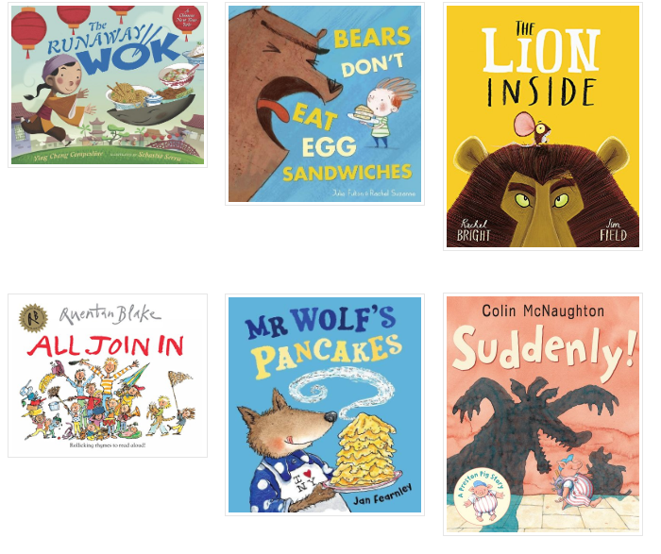
Suggested Reading List for Reception


