

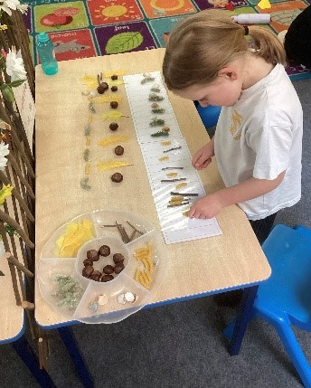
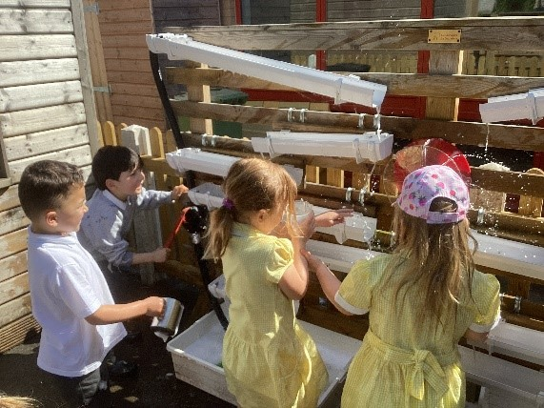

Mrs Manning’s Message
Dear Parents and Carers,

Welcome back! We hope you all had a restful and enjoyable Easter break. It has been a real pleasure to see so many smiling faces coming through the school gates this week – both children and parents! The sun has certainly made our return even more enjoyable, and it feels like the perfect start to the summer term.

The children have come back full of energy and enthusiasm, and we’ve been so impressed by how quickly they’ve settled back into their learning. Classrooms have been buzzing with curiosity, creativity and a real sense of purpose.

This half term, our HEART value is Team Trinity. We’ll be focusing on what it means to work together, support one another, and be part of a kind, inclusive community. We encourage you to talk with your children at home about how they can be a good team member – whether it’s helping a friend, listening carefully, or playing cooperatively.
As the weather warms up, please remember the importance of sun safety. We ask that all children come to school with:
- A hat to wear during outdoor activities
- A water bottle (clearly labelled) so they stay well-hydrated
- Sunscreen applied before school, and a named bottle of sunscreen in their bag if they need to reapply – please note that sunscreen should be for individual use only and not shared between children.

We’re looking forward to an exciting and sunny half term ahead, full of learning, laughter, and teamwork!

House Points
Raglan 312
Ludlow 273
Goodrich 259
Chepstow 354

News and updates:
As always EYFS have been making the most of every opportunity for learning. In English the children shared and wrote their Easter News and in Maths they used natural resources to make repeating patterns. They also enjoyed pretending to be a vet in the role play area and playing outside with the water wall working the pumps and pouring the water down the guttering. What a busy start to the summer term!
Attendance
EYFS 97%
Year 1 96%
Year 2 98%
Year 3 96%
Year 4 98%
Year 5 97%
Year 6 97%
Whole school 97%
News and updates: Reading Assemblies
In KS1, Mrs Gulley chose to read 'Rhino Learns to be Polite'. This is a funny story about a rhino
who never uses his manners when he bumps into people, gets his lunch or even when his friends
give him a birthday present! The other animals in the jungle quickly decide that they don't want
to have a friend like rhino. Therefore, he learns to say please, thank you, excuse me and sorry. Using his kind manners helps the other animals feel really happy and helps rhino to build lots of new friendships too. The children loved helping to act out the story. (Mrs Gulley, Year 2)

This week, we celebrated Star Wars Day a little early – "May the 4th be with you!" is a fun play
on words loved by Star Wars fans all around the world. To mark the occasion, I chose to read
‘Ode to Grapefruit, a piece about the life of James Earl Jones, the legendary actor who voiced
Darth Vader in the original Star Wars films. The children learned about his inspiring journey - from overcoming a childhood stutter to becoming one of the most iconic voices in film history. It was a wonderful opportunity to show the children that even challenges can be turned into strengths, and that perseverance and believing in yourself can lead to incredible achievements. (Mr Land, Year 6)

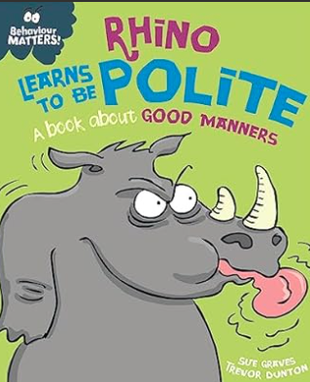

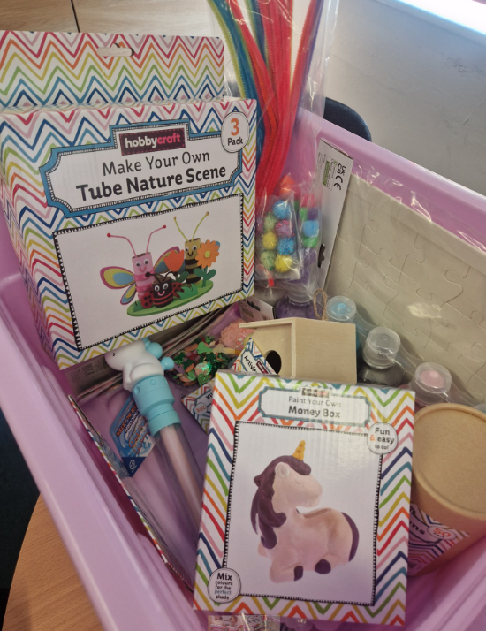
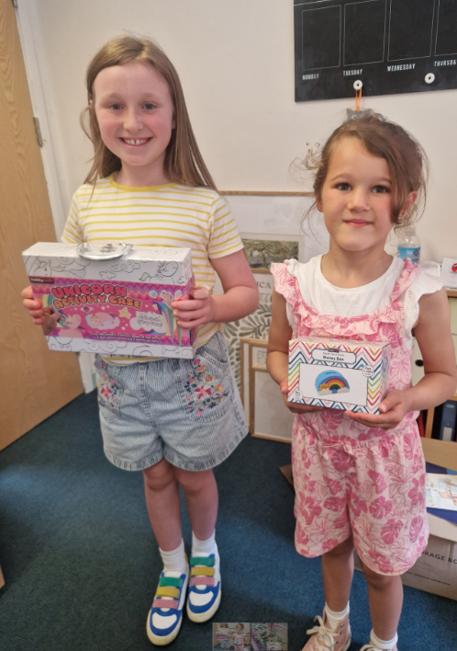
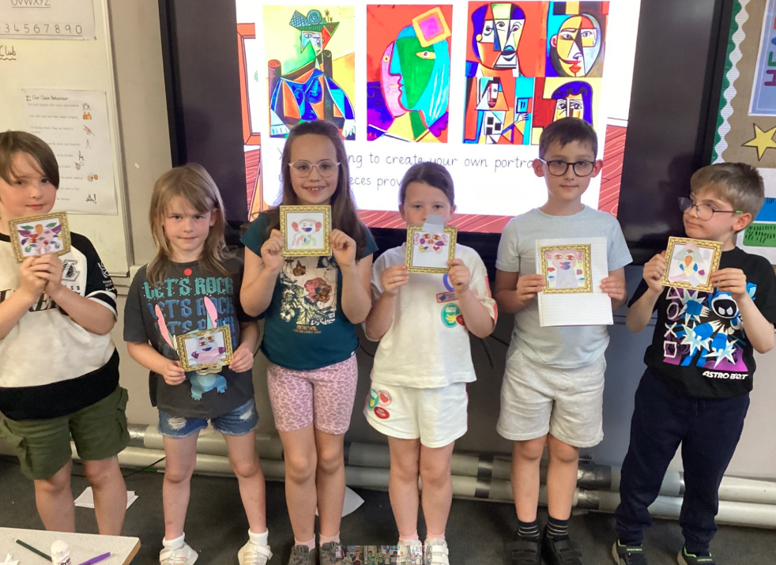
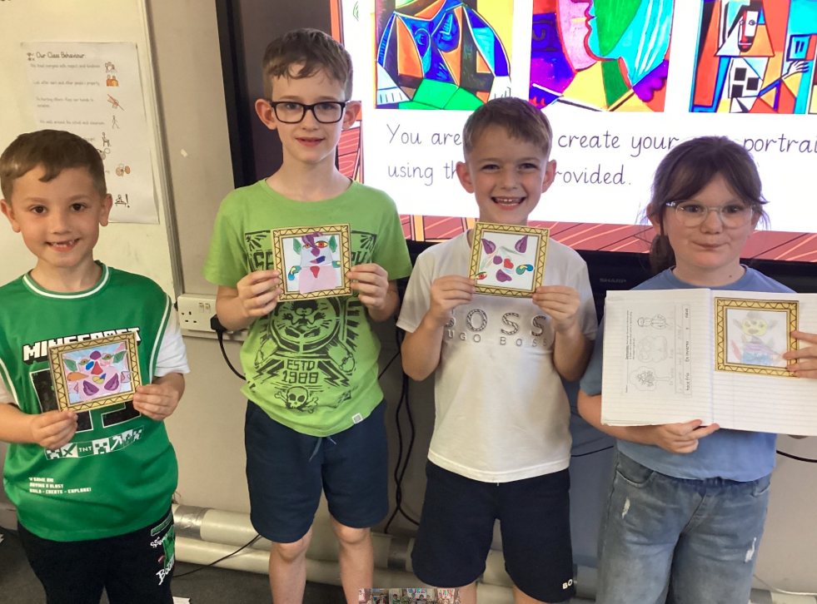
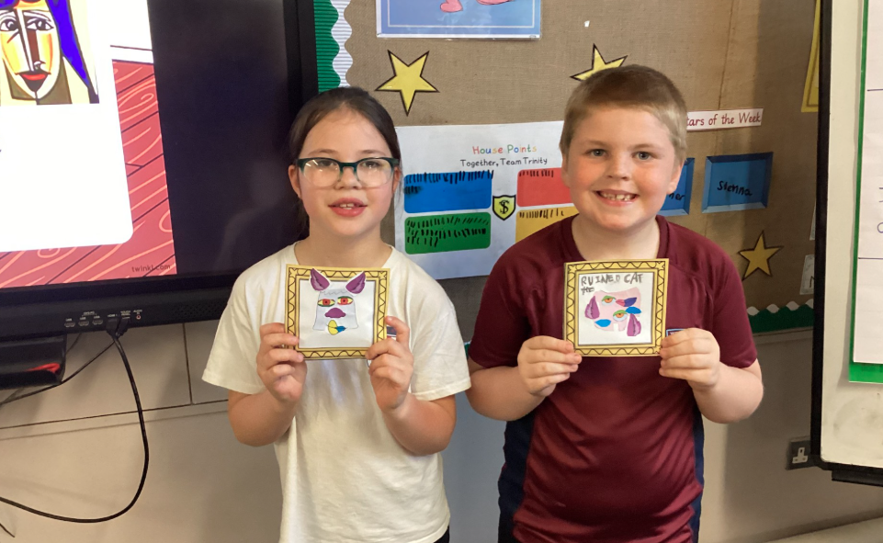
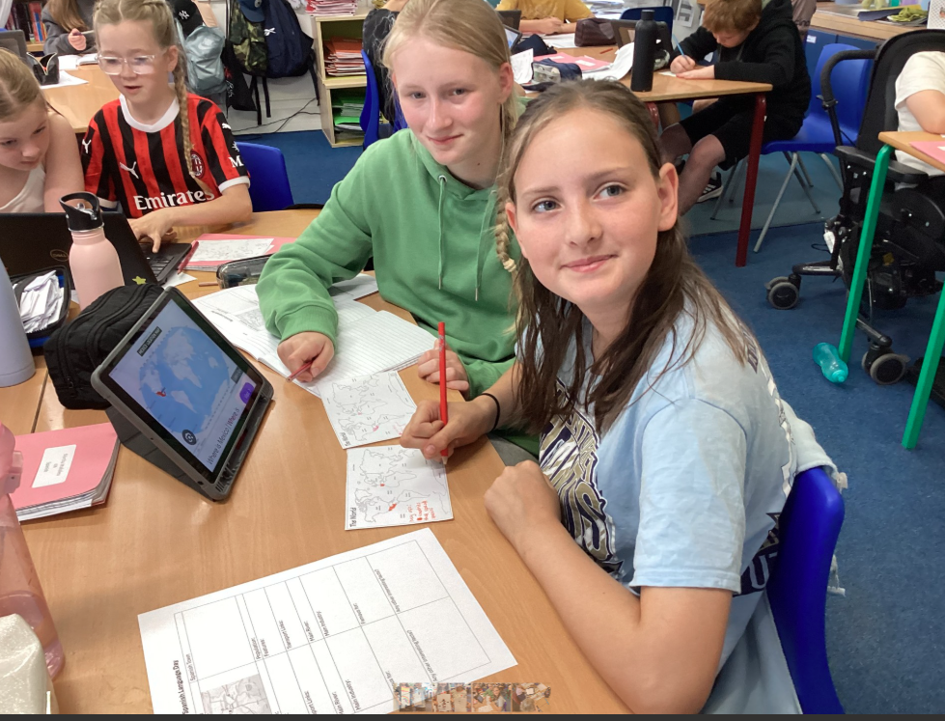
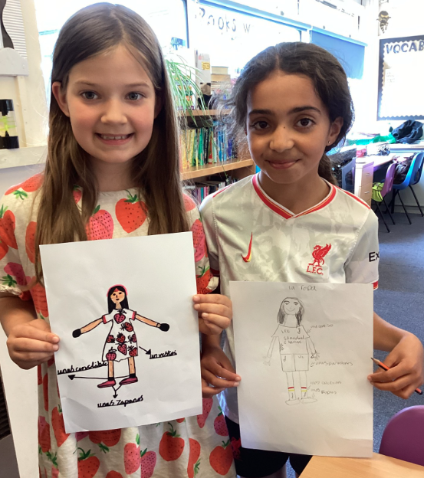
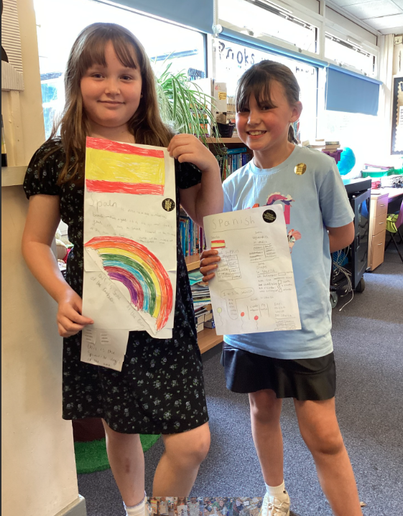
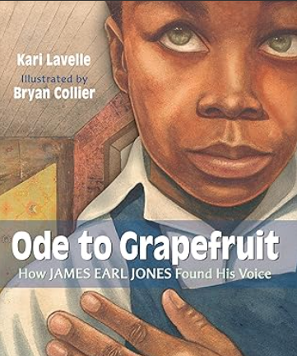

News and updates:
At Trinity, we are proud to celebrate the rich diversity of languages spoken within our community. We recognise the many benefits of multilingualism from boosting brain development to building empathy and opening doors to different cultures. Our commitment to inclusion and unity is at the heart of everything we do, and we celebrate every language and culture that makes up our vibrant school family.
This Friday afternoon, KS2 pupils took part in a special celebration of the Spanish language. Classes explored just how widely Spanish is spoken across the world, discovering that over 20 countries speak Spanish as an official language! Pupils learnt new Spanish words and greetings, sang fun songs, and even delved into the lives of famous Spanish-speaking figures such as Pablo Picasso.

We’re delighted to share some egg-citing news from over the Easter break—Trinity won both 1st and 2nd prize in the Hobbycraft ‘Design an Easter Bonnet’ competition! A huge well done to Orla, who took 1st prize, and Florence, who came 2nd with their wonderfully creative designs. As part of their win, we received boxes full of fantastic craft goodies for the school. Of course, we made sure Orla and Florence had first pick from their prize boxes as a thank you for representing Trinity so brilliantly. We’re incredibly proud of their imaginative work - well done both.

