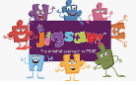

Trinity Primary School – RHSE Knowledge Curriculum
Preparing for the demands of society for the future
Term: Autumn 2 |  |  | Year Group: Year 2 |  |  | Topic: Celebrating Differences
Key Vocabulary |  |  |  |  | Key Questions
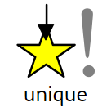 | Being the only one of its kind and unlike anyone else. |  |  |  | What is the ‘Solve it together’ technique? How can it help solve a disagreement between two people?  What is a bystander in a bullying situation? (A bystander is a witness not directly involved).  How could a bystander make a bullying situation worse or better?  What types of bullying do you know about?  Where can someone get help if they were being bullied or witnessed bullying?  How does it feel to give and receive a compliment?  Can you explain how Calm Me time makes you feel?
 | Things that are the same between peers.
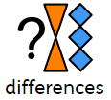 | When someone or something is not similar to others.
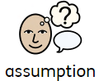 | Judging something and deciding on something without proof.
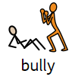 | Someone who makes someone else constantly feel sad or upset by their actions.
 | To include all peers from different backgrounds and genders.
Links to HEART and British Values |  |  |  |  |  |  |  | Wider World Events
HEART  Health- emotional wellbeing and having a healthy mind  Team Trinity- Making people feel welcome, inclusivity  Respect – showing respect to others |  |  |  | British Values  Respect and tolerance- not judging others, making them feel welcome. |  |  |  | BBC Children in Need  Christmas performance  Diwali  Anti-Bullying Week  Odd Socks Day
Assessment
Working towards |  | Working at |  |  |  |  | Working beyond
My friend is good at football but I’m better at art. I like having a pet dog and so does my friend.  I like being friends because we care about each other. |  | Some people get bullied because they look different. They might have different coloured skin or wear glasses.  It feels special to have a friend because I have somebody that I can share things with. People don’t have to be the same to be friends. It is important that we are all special and unique. |  |  |  |  | Stereotypes are unfair. Boys don’t always have to wear blue clothes and girls don’t always have to wear pink clothes. Sometimes stereotypes make people bully each other. If a girl is playing football she can, but some people might think that isn’t right and tease her.  I would stand up for my friend if they were bullied by asking the bully to stop. If my friend was upset I would help them calm down and we would go to tell the teacher together.

