 Trinity Primary School – RHSE Knowledge Curriculum 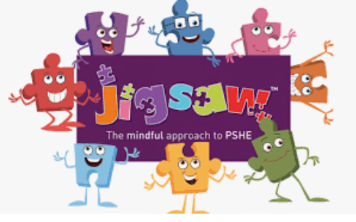
Preparing for the demands of society for the future
Term: Spring 2 |  |  |  | Year Group: Year 2 |  | Topic: Changing Me
Key Vocabulary |  |  |  |  | Key Questions
Change | The process of making or becoming different. |  |  |  | What is a life cycle?  How have you changed since you were a baby?  How will you change over the next year / 5 years / 20 years?  What changes can you / can’t you control?  Which parts are your private parts?  Who is allowed to see them?  What would you do if someone was touching you and you didn’t like it?  Who can you talk to if you ever feel worried or frightened? (at school / at home)  What is your favourite part of Jigsaw lessons?
Grow | To undergo natural development by increasing in size and changing physically.
Control | The power to influence or direct people’s behaviour or course of events.
Life Cycle | The series of changes in the life of an organism.
Baby | A very young child, from birth to 4 years.
Adult | A person who is fully grown or developed. Over 18 in England.
Respect | Regard for the feelings, wishes, or rights of others.
Appearance | The way that someone or something looks.
Physical | Relating to the body, such as physical strength.
Independent | Free from outside control, capable of thinking or acting alone.
Timeline | A line that shows the time and order in which events have happened.
Freedom | The power or right to act, speak or think as one wants.
Responsibilities | Something that is your job or duty to deal with.
Male | Belonging or relating to the sex that fertilizes eggs, and does not produce babies or eggs itself.
Female | Belonging or relating to the sex that can give birth to young or produce eggs.
Vagina | The inside part of a female’s ‘private parts.
Penis | The private part of a boy’s body which gets rid of waste (wee).
Testicles | The two round bags of skin below and behind the penis.
Vulva | The opening and outside parts of a female’s ‘private parts’.
Anus | The opening where a body gets rid of waste (poo).
Public | Done in open view for other people to see.
Private | Private parts of our bodies are special and important parts covered by our underwear or swimwear.
Touch | An act of touching something or someone.
Acceptable | Able to be tolerated or allowed.
Unacceptable | Not allowed.
Comfortable | Relaxed and free from pain.
Excited | Very enthusiastic and eager.
Nervous | Easily agitated or alarmed.
Anxious | Feeling or showing worry, unease about something.
Links to HEART and British Values |  |  |  |  | Wider World Events
HEART  Healthy  Respect  Team Trinity |  | British Values  Mutual Respect  Tolerance |  |  | Safari Park Trip  World Book Day  British Science Week
Assessment
Working towards |  |  | Working at |  |  |  | Working beyond
When I was a baby, I couldn’t talk. Now I can. When I get older, I can learn to drive a car.  Boys have a penis. This is private because it is a special part of my body and I only talk about it when I need to.  Sometimes I don’t like being a girl because people think you have to act in a certain way. |  |  | My vulva is a special and private part of my body. It is important to keep this private by wearing clothes in public because it would be embarrassing not to.  Some touches are meant to hurt. Other touches are kinder.  I like being a girl and doing ‘girly’ things with my Mum. Some of my friends are girls and they like doing other things that I don’t enjoy, like playing sport. |  |  |  | Boys and girls have different private parts like vaginas and testicles, and they may also like to do different things. We wear clothes to keep ourselves covered to keep our privacy. It would not be polite to talk about private body parts unless it was a special time, like in school, with my Mum or with a doctor.  Some people might be worried about getting older because they are scared about moving to a different class in school. I am not worried because I am looking forward to learning new things. They might not be thinking about the good parts of the change, and just thinking about the things that worry them.

