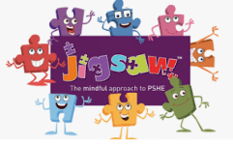
Trinity Primary School – RHSE Knowledge Curriculum
Preparing for the demands of society for the future

Term: Summer 1 |  |  |  | Year Group: Year 2 |  |  |  |  | Topic: Healthy Me
Key Vocabulary
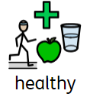 | Being mentally and physically fit and well. |  |  |  | 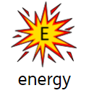 |  |  | What is needed and used to be active and build strength.
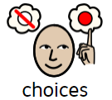 | A choice is the act of choosing something from a range of options. |  |  |  | 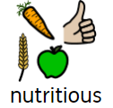 |  |  | Food that contains substances that help your body to be healthy.
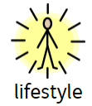 | The way you live your life this can include your attitude, style and things you own. |  |  |  | 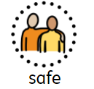 |  |  | Free of harm or danger.
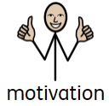 | Wanting to do something. |  |  |  | 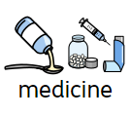 |  |  | Tablets or liquid used to cure a disease or treat a condition.
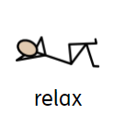 | To make less tense. |  |  |  | 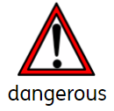 |  |  | Something that could cause pain, harm, injury or loss.
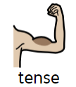 | When something like your muscles become stiff and tight. |  |  |  | 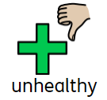 |  |  | Bad health or options that might not help keep your body healthy.
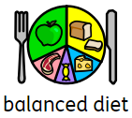 | Eating the right portions of the different food groups to keep your body and mid healthy. |  |  |  | 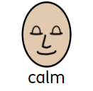 |  |  | Not having strong emotions, linked to being relaxed.
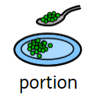 | The amount of something.
Key Questions
- What does your body need to stay healthy?  - What does relaxed mean?  - What makes you feel relaxed / stressed?  - What healthy snack shall we make and eat together? |  |  |  |  |  | - What snacks could you eat before exercise?  - How can Calm Me time help you stay healthy?  - What types of medicine have I given you? What are they for?
Links to HEART and British Values |  |  |  |  |  |  |  |  |  | Wider World Events
HEART  Health:  - Investigate healthy food; talk about having a healthy relationship with food and making healthy choices.  - Talk about medicines, how they work and how to use them safely  - Discuss things that make them feel relaxed and stressed. |  |  | British Values  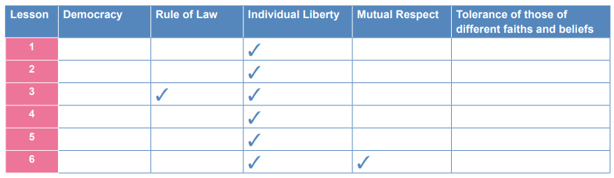  - Individual liberty: Making own choices of food and selecting appropriate portions of food options.  - Rule of law: There are age restrictions on certain products and the government have guidance for medicines. The government suggest the amount of certain food groups people should consume daily.  - Mutual respect: understanding that some people will make different lifestyle choices |  |  |  |  |  |  | - Creating own cereal in DT work  - Sports day (Summer 2)
Assessment
Working towards |  | Working at |  |  |  |  | Working beyond
I can tell you some things I can put in or on my body to keep it healthy.  I can say how I feel about being healthy. |  | I can explain why foods and medicines are good for my body comparing my ideas with less healthy/ unsafe choices.  I can compare my own and my friends’ choices and can express how it feels to make healthy and safe choices. |  |  |  |  | I can justify my choices about food and medicines and explain healthy and safe ways in which they are good for my body.  I can give evidence as to why my own and my friends’ choices are healthy / less healthy. I can also evaluate how it feels to make healthy and less healthy choices.

