Welcome to Year 3

Dear Parents,

We hope you’ve had a relaxing Summer break and we cannot wait to welcome your children into Year 3 for the new school year. We have an exciting year ahead of us with lots of excellent learning opportunities, and we look forward to working with your children and meeting you all.

The year group is divided into 3 classes:
3L is taught by Miss S Lawrence
3C is taught by Mr N Collins
3W is taught by Mr B Walker

This year group is further supported by the following LSA’s: Mrs J Hall, Mrs J Hussey, Mr J Collingwood

English
This year, we will be reading and writing a wide range of different text types and genres, fiction and non-fiction through our English lessons. This term, we will be reading ‘The Lion, Witch and the Wardrobe’ by C.S Lewis. In the second part of the term, we will be reading ‘The Minpins’ by Roald Dahl. To link to our history topic, we will begin writing lessons with The Stone Age Boy where children will write their own narrative based on this text. We will then have the opportunity in the second part of the term to explore poetry, where children will have a go at writing a seasonal poem, before exploring the genre of persuasive writing, where they will try to convince people to come and stay in a ‘Stone Age resort’.

Your child will be bringing home one of our level-appropriate books from our reading scheme. We are asking our children to read five times a week at home for homework and we ask for your support in this by recording their reads on ‘BoomReader’ and discussing their reading with them. Along with the book the children are allocated from our reading scheme, they will also take home a book of their choice from our class library- this could be for them to read themselves or to be read to by an adult. All children who read five times a week will be entered into a half-termly draw where they have the chance to win a prize. We will be sending home new logins for Boomreader this week, and it would be great if you could listen to your child read as much as possible at home and log on Boomreader when you do. Please contact your class teacher if you have any difficulties with login into Boomreader.

Mathematics
We will start our year of mathematics by looking at Place Value, before progressing onto addition, subtraction, multiplication and division as we begin to explore these 4 operations, through written methods and mental strategies. These will form a strong foundation for further learning throughout the year when looking at other topics within mathematics. We will be learning and practising tables in Maths lessons and would appreciate it if you could encourage your children to continue learning them at home, using their TT Rockstars log in. We will send these logins out again this week.

Other areas of the curriculum
This term, we will be looking at the Stone Age, Bronze Age and Iron Age in history, where children will explore, compare and observe changes throughout these eras of time. In science, we will begin the term exploring the topic of forces and magnets, and we will have a visit from ‘The Explorer Dome’ who will help to bring this topic to life for the children. They will be visiting on the first Monday (9th September). A letter with the details of this event will be sent out this week with Parentpay details.

P.E.
P.E kits are required to be worn to school on the day of your child’s P.E. lesson. This term, P.E will be on a Tuesday in the afternoon.
The school P.E. kit consists of plain black shorts or joggers, a plain black sweatshirt or hoody, a white t-shirt (with or without the school logo) and trainers. Please ensure that if your child wears earrings to school, these are either removed by the child themselves or taped up with tape provided from home.

P.P.A (Swimming, P.E and Music)
3L are swimming in the first term and therefore will need their swimming kit every Thursday. They should come into school in their school uniform.
3C and 3W should come into school in P.E. kit on Thursday for PPA as one of their sessions will be P.E based.
This year, we will be running PPA in set week blocks, so 3C’s first swimming session will be Thursday 12th September. The final swimming session for 3L will be Thursday 12th December. 3C will begin their swimming block on Thursday 19th December.




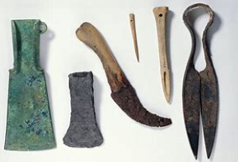











Snacks
Now that children are moving into year 3, they will no longer be provided with free fruit/vegetables at break time. If you wish your child to have a snack at break, please send this in with them daily. A gentle reminder that this is a snack of fruit or vegetables only.

Uniform
Correct school uniform must be worn at all times, and all garments must be labelled with your child's name. The labelling of PE kit and bags would also be extremely beneficial! Please can we also remind you about your child’s hair accessories ensuring that they are in line with school expectations. Hair accessories should be small, plain, simple and in the school colours of yellow, grey or hair coloured. Your child will be asked to remove them if they do not comply.

Pencil cases & Toys
If your child would like to bring a pencil case, they may use them for special projects or wet play. All equipment that they need for lessons will be provided.
We have a no toy policy, including clip on toys on bags, please could you help your child keep toys for home.

Timetable
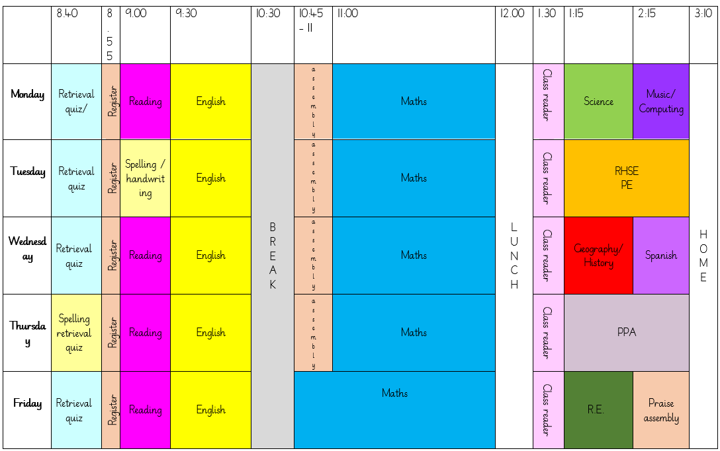

Key Dates:
- Wednesday 5th September 2024 – Autumn term begins
- Monday 9th September 2024 - Explorerdome Science visit (coming to school)
- Wednesday 18th September 2024 - Meet the Team Parent meeting- 5pm – further details to follow soon
- Friday 20th September 2024- Flu Vaccines
- Monday 21st October 2024- Pupil photographs
- Thursday 24th October 2024 – last day of Autumn 1 (INSET day- Friday 25th October)
- Tuesday 22nd and Thursday 24th October 2024- Parent consultation meetings
- Friday 20th December 2024 – last day of Autumn 2

Staff email addresses
If you wish to contact your child’s class teacher, then please do so using the email addresses shown below:
Miss S Lawrence- slawrence@trinity.hereford.sch.uk
Mr N Collins ncollins@trinity.hereford.sch.uk
Mr B Walker- benwalker@trinity.hereford.sch.uk

Please be aware that staff may be busy with teaching responsibilities but will respond during working hours at the earliest possible convivence. To support the wellbeing of all staff, teachers will not be contactable after 5.30pm. We would kindly ask you to be respectful during communications with school staff.

Many thanks,

The Year 3 Team

